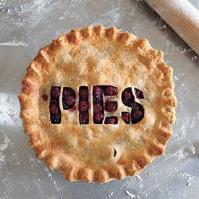
Holiday Pie Sale!
A Delicious Way to Support
SSMH Auxiliary

- Order now through November 18 to enjoy for the Holidays
- Pies can be picked up on Tuesday, November 26 from 7 a.m. – 5 p.m. Pine Grove Café’
All Pies Only $10 each – All Pies 10”
Some pies can be ordered baked or unbaked

Traditional Pies Available No Sugar Added
Apple Apple
Pumpkin Blueberry
Pecan Lemon Meringue
Fruit of the Forest
Banana Cream
Chocolate Cream
Coconut Cream

3 EASY WAYS TO ORDER YOUR PIE…
- Order from an Auxiliary Member
- Order Hospital Gift Shop
(Main Lobby Area)
- At Volunteer Services office 1st FL (570) 723-0191 or prestonf@upmc.edu

Name______________________________________________Phone____________________
Address______________________________________________________________________
E-mail____________________________________________
Traditional 10” Pie: Qty Baked/Unbaked
B/U
Apple Pie _____ _____
Pumpkin _____ _____
Pecan _____ B only
Fruit of the Forest _____ U only
Banana Cream _____ B only
Chocolate Cream _____ B only
Coconut Cream _____ B only
No Sugar Added 10”: Qty Baked/Unbaked
B/U
Apple _____ U only Blueberry _____ U only
Lemon Meringue _____ B only
Payment amount$____________
Cash / Check#________________________
(Checks payable to SSMH Auxiliary)
Payroll Deduction ______ (fill out PD form)
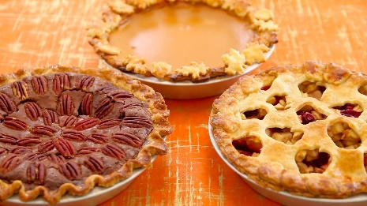
Payment due when ordered.

